**Building A Restaurant Website With Bootstrap.**

**Developer Name:** Surekha Potu

This document contains contents for:

* Project Description
* Flow of the Application
* Core concepts used in project
* Conclusions

**1.Project Description:**

Build a responsive website for a restaurant where users can read the details of the restaurant.

* You are a web developer at a service-based web development company called Kite Technologies.
* The company has been approached by a client who wants to build a website for their restaurant named Ming’s Diner.
* The website should provide the users a brief overview of the restaurant and its bestsellers, its address, as well as an option to contact the restaurant.
* During sprint planning, you agree to lead this project and develop the website.
* Building the website using HTML
* Adding Bootstrap to the website
* Adding a landing page, a navbar, a CTA button, a grid, and a footer
* Adding a contact form for users to contact the restaurant
* Pushing the code to the git repository

**2.Application Flow:**

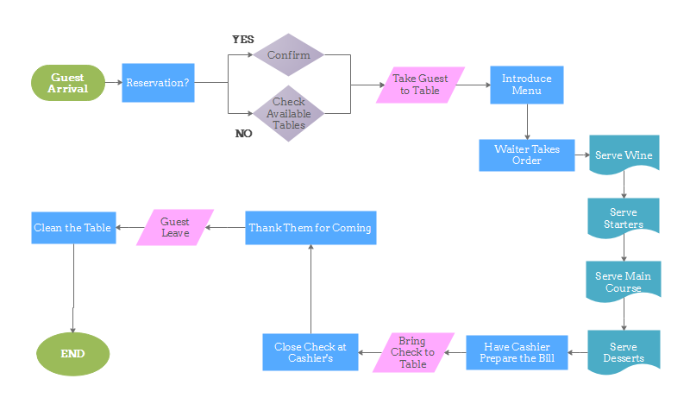

**3.Core concepts used in project:**

● HTML: To define the content of the website  
● Bootstrap: To build the website  
● JavaScript: To handle events and responses  
● JQuery: To include JavaScript plugins like modals, tooltips, etc.

**4.Conclusions:**

This project is designed to create building a Restaurant Website With  using Bootstrap.